**PRESS NOTE**

FOR IMMEDIATE RELEASE

**PLASTINDIA 2026 Launched: Propelling India’s Plastics Industry Towards Sustainability, Innovation and Global Leadership**

*The Plastindia Foundation unveiled PLASTINDIA 2026, spotlighting the plastics industry’s vital role in India’s economic growth and sustainability. Hon’ble Commerce Minister Shri Piyush Goyal called for innovation and a target of 20% annual growth rate. The event highlighted ambitious plans for a zero-waste exhibition and the industry’s commitment to education, innovation, environmental responsibility and global collaboration for future success.*

The Plastindia Foundation officially launched **PLASTINDIA 2026**, the 12th edition of the prestigious international plastics exhibition, conference and convention, at a grand ceremony held at the Grand Hyatt in Mumbai on 23rd August, 2024. Graced by the Hon’ble Minister of Commerce and Industry, Government of India, Shri Piyush Goyal, who inaugurated the launch, underscoring the pivotal role of the plastics industry in India’s economic growth, sustainability goals and its journey towards becoming a developed nation.

The packed house during the launch witnessed unprecedented enthusiasm along with convergence of industry leaders and stakeholders from around the globe. Along with Shri Piyush Goyal and Shri Sunil Singhi, Hon’ble Chairman of the National Traders’ Welfare Board, Ministry of Commerce & Industry, Government of India; Alok Tibrewala, Chairman of the National Executive Council for PLASTINDIA 2026; Ravish Kamath, President of the Plastindia Foundation; Raju Desai, Vice President of the Plastindia Foundation; Dharmendra Gandhi, Hon. Treasurer of the Plastindia Foundation; Pradeep Rathod, Chairman of the National Advisory Board of the Plastindia Foundation; Thomas Franken, Director K, Portfolio Plastics & Rubber at Messe Düsseldorf GmbH; and Jigish Doshi, Immediate Past President of the Plastindia Foundation, set the tone for the event.

A highlight of the evening was the symbolic lighting of the lamp ceremony. Utilising an innovative LED diya whose circuit completed with water, the attendees, seated at their individual tables, collectively poured water into the diya, illuminating it and signifying unity and collective effort.

**A Catalyst for Growth and Innovation**

In his keynote address, Shri Piyush Goyal commended the plastic industry's positivity, enthusiasm and commitment. He acknowledged the substantial contributions of the Plastindia Foundation and the plastics sector to India's economic growth. Particularly impressed by the industry’s modest request for collaboration, he emphasised the immense potential the plastics industry holds for India.

Shri Piyush Goyal urged industry leaders to harness India's talent and skills, stressing the importance of economies of scale, innovation and technology adoption to enhance competitiveness. "It's time we start capturing world markets, taking confident strides towards self-reliance, and engaging with the rest of the world from a position of strength," he remarked.

He revealed that both the Hon’ble Prime Minister Shri Narendra Modi and the Hon’ble Home Minister Shri Amit Shah have expressed strong support for the plastics industry, recognising its significant contribution to employment and its bright future. Shri Piyush Goyal highlighted the Prime Minister's particular closeness to the plastics sector.

Announcing plans to host the CEO’s conclave alongside PLASTINDIA 2026 in the prestigious Leader’s Summit Room - where the G20 Summit was held - Shri Piyush Goyal invited industry leaders to be his guests for an evening of interaction and dinner. He encouraged the Plastindia Foundation to consider hosting the exhibition more frequently, given the rapid advancements in the plastics industry.

Setting the tone for future endeavours, he proposed the tagline ‘**Bharat Forever’** for subsequent editions of PLASTINDIA, emphasising the lasting impact the industry will have on India's future. Shri Piyush Goyal envisions India hosting not just world-class, but the world's largest exhibitions, aligning with the nation's aspiration to become a developed nation - a ‘***Viksit Bharat’****.*

He underscored the need for bold thinking and ambition, stating, "If India wants to become the third-largest economy by 2027, grow from a USD 3.5 trillion economy to a USD 35 trillion economy in the next 25 years, and provide prosperity and a better quality of life to every single child born here, then it's time to think big." He added that embracing technology and modern advancements will position India at the forefront of global progress.

Shri Piyush Goyal encouraged the plastics industry to aim for a 20% annual growth rate, surpassing the country’s nominal GDP growth of 11%. He highlighted that today, plastics is creating its impact and finding newer applications across industries. Plastics provide all the ingredients that the modern world is looking for, like its versatility, durability, flexibility and lightweight properties that meet modern demands. "We should aspire to increase our global trade share from the current 1.8% to 20% and eventually reach USD 100 billion in exports," he urged.

Expressing confidence in India's ability to overcome challenges, he stated, "There will be a million problems, but we have a billion minds to solve them." He assured that the government is willing to take every possible step to support the plastics industry, emphasising the importance of quality standards to prevent the influx of substandard imports as we have the capability to do better than them.

Addressing environmental concerns, Shri Piyush Goyal advocated for a greater focus on the circular economy.

**Government Support and Collaboration**

Shri Piyush Goyal assured industry stakeholders of the government’s unwavering support. He announced the formation of a dedicated team from the Department for Promotion of Industry and Internal Trade (DPIIT) within the Ministry of Commerce and Industry to assist the Plastindia Foundation for any requirements from any State or Central Government so as to address any challenges faced by the sector.

**Acknowledging Industry Leaders, Sponsors and Industry Status**

Ravish Kamath extended a warm welcome to all dignitaries and participants. He highlighted the significant contributions of key industry players, whose support has been instrumental in the sector’s growth, and underscored the indispensable role of plastics in modern life and India's journey towards becoming a developed nation.

He acknowledged the unwavering support from major sponsors, including Reliance Industries, Lohia Corp, Supreme Industries, Alok Masterbatches, Cosmo Films Ltd., HPCL-Mittal Energy Ltd., IVL Dhunseri Petrochem Industries and Neelgiri Machinery Global Pvt. Ltd.

He detailed the remarkable growth of the Indian plastics industry over the past decade. The industry expanded from a market size of USD 15 billion in 2010 to over USD 37 billion in 2023 and is projected to reach USD 50 billion by 2026. Employment in the sector currently stands at approximately 4 million people, expected to grow to 5.5 million by 2026.

He emphasised the industry’s substantial contribution to the Indian economy, accounting for approximately 1.5% of India's GDP in 2023, with expectations to reach nearly 2% by 2026. India's plastic exports have also seen significant growth, with exports worth approximately USD 10 billion in 2023, projected to increase to USD 15 billion by 2026.

**PLASTINDIA 2026: Bharat Next**

Alok Tibrewala expressed his appreciation for the Minister’s presence and support. He unveiled the theme for PLASTINDIA 2026, **‘Bharat Next’,** symbolising the growth of the plastics industry across all sectors and its commitment to innovation.

Ambitious plans for PLASTINDIA 2026 were announced, aiming to make it the world's largest plastics exhibition. Scheduled to be held from 5th to 10th February, 2026 at the Bharat Mandapam (Pragati Maidan) in New Delhi, the event aims to cover the entire 5,00,000 square metres of this mega venue, accommodating over 1,500 domestic exhibitors and 500 international participants. An expected footfall of over 6,00,000 visitors underscores the event's magnitude.

In order to meet the enormous industry demands, in addition to the 20 halls, we are also considering the construction of world-class temporary structures for the event. The focus is on enhancing the visitor experience through technological advancements, including a dedicated mobile app, improved networking facilities and efficient services. In a significant move, the Plastindia Foundation has booked almost the entire Convention Centre for four days to host the biggest conferencing, convention and workshop the industry has ever seen.

An industry first, PLASTINDIA 2026 will be a zero-waste exhibition, ensuring no waste from the exhibition grounds goes to landfills. To enhance the visitor experience, the concept of a **‘Tatkal Gate’** is being explored for seamless entry.

A special promotion was announced: exhibitors who book booth space before 31st October, 2024 will receive a special discount of Rs. 800 per square metre. Those who participated in PLASTINDIA 2023, will get an additional Rs. 800 per square metre as a loyalty discount.

**Global Perspectives**

Addressing the gathering, Thomas Franken emphasised the importance of global collaboration. He expressed confidence in the event's potential to attract participants from around the world.

He highlighted the themes of the upcoming K Show in Germany, focusing on the circular economy, sustainable practices and technological innovations shaping the industry's future. "These themes will also play a significant role in the next edition of PLASTINDIA in 2026," he added.

Thomas Franken underscored emerging trends and the need for the industry to adapt to global shifts, particularly in technology and market demands.

**Education and Skill Development**

Ravish Kamath highlighted that the cornerstone of the industry's future lies in education and skill enhancement. The **Plastindia International University (PIU)**, located in Vapi, Gujarat stands as a testament to this commitment. Dedicated to plastics and sustainability, PIU aims to nurture the next generation of industry professionals. Investment in education is seen as crucial for fostering innovation and expertise in the plastics domain.

**Industry Opportunities**

Pradeep Rathod addressed the evolving landscape of the plastics industry, acknowledging the opportunities and challenges posed by technological advancements, regulatory changes and shifting public perceptions. He emphasised the collective responsibility to navigate these changes with foresight and determination. He underscored the need for the industry to champion sustainable practices, enhance collaboration and embrace technological innovations to remain globally competitive.

**A Call to Ambition**

In his concluding remarks, Shri Piyush Goyal emphasised that innovation is the way forward. He urged industry captains to have dedicated teams and to be bold in their aspirations. "If we all come together with new ideas and innovate new products, the industry will grow, employment will increase for millions, and our businesses will flourish," he stated.

He highlighted India's journey toward self-reliance (**Atmanirbhar Bharat**) during the ‘**Amrit Kaal’**, as the nation marches toward becoming a developed country. He noted that India has transformed from being a fragile economy to the world's fifth-largest economy, with substantial foreign exchange reserves. "According to every survey, the next few decades belong to India," he affirmed.

Shri Piyush Goyal acknowledged the significant contribution of plastics to every person's life and lifestyle, urging the industry never to underestimate its impact. "Your contribution is nothing less than service to the country," he said. He encouraged the industry to embrace best practices, innovation, technology, economies of scale and high quality, asserting that with these, there is no stopping India's progress.

He concluded with confidence, stating, "Let us decide that India's plastics industry will be the best in the world. Remember, the Indian plastics industry is second to none. With quality, innovation and technology, we can achieve greatness." Quoting actor Shah Rukh Khan, he added, "If we desire something earnestly, the universe conspires to make it happen."

**Looking Ahead**

Raju Desai delivered the vote of thanks, expressing gratitude to all the speakers, attendees, sponsors, exhibitors, partners, the organising team and the media.

“As we look forward to PLASTINDIA 2026, we are filled with optimism and determination,” he said, “This event will not only showcase our industry's strengths, but also pave the way for future advancements.”

He invited guests to participate actively in the upcoming exhibition and to join in collaborative efforts to drive the industry forward.

**Closing Note**

The event concluded with networking opportunities and a dinner, fostering camaraderie among industry participants. The atmosphere was one of enthusiasm and collective resolve to make PLASTINDIA 2026, a resounding success.

**About Plastindia Foundation**

Established in 1987, PLASTINDIA FOUNDATION is the apex body of the major association, organizations, and institutions connected with Plastics focused to promote the development of the plastics industry and assist in the growth of Plastics and related materials. The Foundation is a nonprofit organization committed to the nation’s growth through the development of the Plastics sector. The aim of the Foundation is to facilitate the export-led growth of the Indian Plastics industry and help boost exports both in volume and revenues. It aims to make India the number one destination and the preferred sourcing base of Plastic products in the world.

**Contact Information**

**Shital Patel**

**Sr. P R & Communication Manager**

**Plastindia Foundation**

**Email – pr.shital@plastindia.org**

**Pictures**

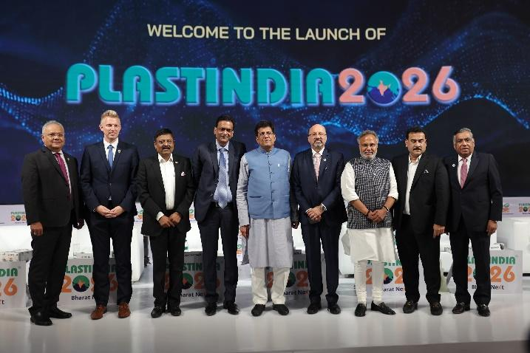

**A Distinguished Head Table!**

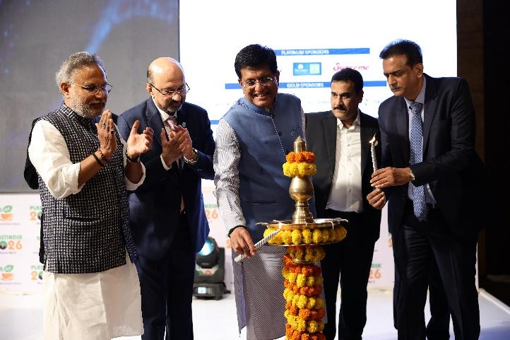

**Lighting the Lamp of Knowledge!**

**The Most Awaited Moment!**

**A Mesmerising Talk by Hon’ble Minister of Commerce and Industry,**

**Government of India, Shri Piyush Goyal.**

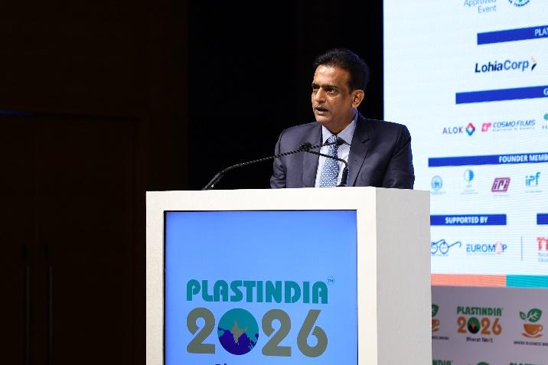

**A Vision that Spellbound the Industry, Alok Tibrewala, Chairman of the National Executive Council for PLASTINDIA 2026, addressing the gathering.**

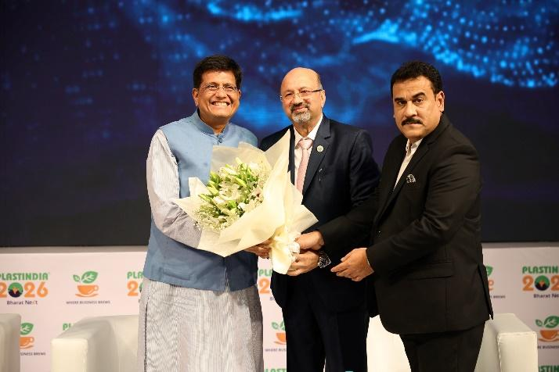

**Expressing Gratitude!**